Courtship in Cross-Sex Friendship:

Novel Tests of Male Financial Provisioning as a Signal and Cue of Mating Interest

Ryan Dobson*

University of New Mexico, Albuquerque

William Costello*

University of Texas at Austin

David M. G. Lewis

Murdoch University

*Indicates shared first authorship

Abstract
Cross-sex friendships are often characterized by psychological and behavioral patterns consistent with underlying mating motivations, and many romantic relationships begin as friendships. Despite the prevalence of mating outcomes in cross-sex friendships, little is known about the courtship behaviors in cross-sex friendships that translate into these outcomes. Guided by parental investment theory, sexual economics theory, and the principle that courtship behaviors are calibrated to the mate preferences of the courted sex, we elaborated and tested multiple novel predictions about a candidate courtship behavior in cross-sex friendships: financial provisioning. Findings provided robust support for half a dozen sex-differentiated predictions. First, men (N = 147) reported that they pay for more of bills shared with cross-sex friends, a perspective corroborated by reports from women (N = 441). Second, men’s, but not women’s, interest in mating with their cross-sex friends predicted their financial provisioning behavior. Third, women, but not men, perceived cross-sex friends who financial provision them to be more interested in mating with them. Notably, all these findings were explained as between-person differences rather than within-person effects. That is, men did not provision some female friends more than others depending on their attraction to those specific friends. Rather, some men consistently provisioned across their cross-sex friendships, whereas others did not. This pattern suggests that some men are inclined to view cross-sex friendships as mating opportunities whereas others do not, which may help explain some of the variation in platonic versus mating outcomes of cross-sex friendships. Collectively, these findings offer multiple new insights into the psychology underpinning cross-sex friendships.

Courtship in Cross-Sex Friendship:

Novel Tests of Male Financial Provisioning as a Signal and Cue of Mating Interest
Cross-sex friendships are frequently characterized by patterns of psychology and behavior that suggest such bonds may often be underpinned by mating motivations. For example, the traits that people report desiring in cross-sex friends closely align with the traits they seek in mates (Lewis et al., 2011, 2012; Szymkow & Frankowska, 2022), approximately fifty percent of people report experiencing sexual attraction in a cross-sex friendship (Bleske-Rechek et al., 2012; Halatsis & Christakis, 2009), and a similar proportion report having had sex with a cross-sex friend (Afifi & Faulkner, 2000). A recent meta-analysis also found that approximately 66 percent of romantic relationships began as friendships (Stinson et al., 2022).
Despite the prevalence of these mating outcomes that emerge from cross-sex friendships, little is known about the means by which people signal and perceive mating interest in such friendships. Courtship behaviors, also referred to as tactics of mate attraction, are actions strategically deployed to attract or escalate a mating relationship by signaling desirable qualities to a potential mate (Buss, 1988), and they are one pathway by which mating motives may surface in cross-sex friendships.
Although both males and females may deploy courtship strategies within cross-sex friendships, there are several strong theoretical reasons that male-initiated behaviors may be both more frequent and more overt, making them a theoretically fruitful starting point for studying how courtship manifests in cross-sex friendships. First, although humans exhibit mutual mate choice (Stewart-Williams & Thomas, 2013), asymmetries in parental investment result in men—the lower investing sex—typically competing more intensely for access to mates (Trivers, 1972). Second, these evolved sex differences are reflected in contemporary social norms, which continue to prescribe that men are the primary initiators of romantic pursuit (Ömür & Büyükşahin-Sunal, 2015; Eaton & Rose, 2011). Third, empirical evidence shows that men, more than women, view their cross-sex friendships as potential mating opportunities (Afifi & Faulkner, 2000; Bleske-Rechek et al., 2012; Halatsis & Christakis, 2009).
Financial Provisioning as a Courtship Tactic
We should expect the precise form of courtship behaviors in cross-sex friendships to be guided by the mate preferences of the opposite sex (see Buss, 1988 for a detailed discussion of this idea as it applies to explicitly mating contexts). Because women, compared to men, incur higher obligatory costs of reproduction (e.g., pregnancy, childbirth, lactation; Trivers, 1972), their reproductive success has recurrently depended on access to long-term investing partners throughout evolutionary history (Symons, 1979). These ancestral selection pressures shaped the evolution of female mate preferences for a partner’s capacity to acquire and willingness to share resources (Buss, 1989).
In contrast, men’s reproductive success was more directly limited by access to fertile mates than by their partner’s provisioning ability, which reduced selection pressure for a parallel preference in men (Symons, 1979). This sex-differentiated preference is cross-culturally robust. Across societies, women consistently rank a partner’s ability to acquire and invest resources as a key criterion in long-term mate choice, whereas men do not (see Buss & Schmitt, 2019 for a review). This female preference in turn would have created selection pressures for male tactics to display traits associated with resource provisioning.
The underlying logic of what is now termed sexual economics theory (Baumeister & Vohs, 2004) was first articulated in parental investment theory (Trivers, 1972) and extended by Symons (1979), who argued that because females of many species, including humans, bear higher obligatory reproductive costs, they function as the limiting reproductive resource and thus as gatekeepers to sexual access. This framework explains why men, as the lower-investing sex, compete more intensely and frequently channel resources into courtship behaviors designed to increase their mating prospects. Evidence for this dynamic is widespread across species, for example, many male insects provide nuptial gifts (Vahed, 1998), and primate males sometimes exchange food for mating opportunities (Gomes & Boesch, 2009). In humans, male financial provisioning can likewise be understood as a manifestation of this general evolutionary pattern.
Robust evidence supports this view. Men, more than women, conspicuously display wealth and generosity to attract mates (Buss, 1988; Schmitt & Buss, 1996; Sundie et al., 2011; Kruger, 2008). Men across cultures consistently are more likely than women to use strategies focused on acquiring and showcasing material resources to enhance their mate value (Apostolou et al., 2023). Experimental research also shows that visual exposure to attractive women causes men to elevate the importance they place on resource acquisition goals (Roney, 2003), and that mating cues prompt men, but not women, to display greater economic generosity (Chen et al., 2025). Similarly, men contribute more to charity when observed by a female rather than a male or no observer, whereas women’s generosity does not vary by audience, supporting the idea that men’s financial generosity may function, in part, as a mating signal (Iredale et al., 2008). Men also use gift-giving as a courtship strategy, and women tend to interpret such gifts as cues of mating interest (Jonason et al., 2009; Komiya et al., 2019). Research also shows that both men and women tend to interpret male financial provisioning as a flirtation tactic (Wade & Feldman, 2016; Kennair et al., 2022).
Male financial provisioning and conspicuous displays of resources do not merely function as honest signals of underlying mate value, but can also operate within the more transactional dynamics emphasized by sexual economics theory (Baumeister & Vohs, 2004). On this view, men channel resources not only to signal their qualities but, in part, to cultivate or maintain access to potential mates (Baumeister et al., 2017).
The Current Study
Connecting these three bodies of evidence – (i) cross-sex friendships frequently are associated with mating motivations, (ii) women, more so than men, have a preference for mates with resource provisioning capabilities, and (iii) selection shaped strategies in men to demonstrate such capabilities to women, leads to the hypothesis that men may engage in financial provisioning in cross-sex friendships as a courtship tactic (Bleske & Buss, 2000).
In line with this hypothesis, which we refer to as the Provisioning as Courtship in Friendship (PCF) hypothesis, (1) women report that, when they go out with their male friends, those friends more often pay, and (2) women, but not men, rate ‘gifts’ and ‘dinners’ as key benefits of cross-sex friendships (Bleske & Buss, 2000). These initial contributions by Bleske and Buss (2000) were valuable, but their research was characterized by several key limitations. First, they did not test whether male financial provisioning in cross-sex friendships was actually motivated by mating interest. If the PCF hypothesis is correct, then mating interest should be a key predictor of men’s financial provisioning in cross-sex friendships. This was the first central aim of the current paper: to investigate whether men’s interest in mating with a female friend systematically predicts their financial provisioning in cross-sex friendships. This is a new and key test.
Another key form of evidence is whether women’s financial provisioning in cross-sex friendships is not linked to their mating motivations. Given that men do not typically prioritize resource investment when evaluating potential mates (Buss & Schmitt, 2019), we should not expect women who are interested in mating with their cross-sex friends to engage in financial provisioning as a courtship tactic. In other words, the PCF hypothesis generates the “positive” prediction of a relationship between men’s mating interest and their financial provisioning in cross-sex friendships as well as the “negative” prediction of women’s mating interest not predicting their financial provisioning. Testing both the “positive” predicted effect and theoretically expected “negative” effect is a stronger test of a hypothesis than testing the predicted positive effect alone (see Lewis et al., 2017). This was the second central aim of the current study: to test the theoretically expected absence of a link between mating motivations and provisioning behavior among women alongside the predicted association among men, neither of which were confirmed by Bleske and Buss (2000).
Another limitation of Bleske and Buss’s (2000) work is that it did not consider alternative explanations for the observed sex difference in financial provisioning in cross-sex friendships. One such alternative is that financial provisioning in cross-sex friendships by either sex has nothing to do with mating motivations, but rather is simply a consequence of people’s perceptions of the quality of the relationship. If men, more than women, perceived their cross-sex friendships as being higher in relationship quality, and these perceptions predict financial investment, the sex difference reported by Bleske and Buss (2000) would emerge. Recent work (Wahring et al., 2025) suggests that men benefit more from romantic relationships than women because they receive relatively greater gains in intimacy and emotional support. Men and women may similarly derive sex-differentiated benefits from cross-sex friendships, insofar as friendships with women may provide men with emotional support and self-disclosure opportunities that are less readily available to them in same-sex friendships.
In short, Bleske and Buss’s (2000) research cannot rule out this alternative account that is unrelated to mating motivations. A third central aim of the current paper was therefore to elaborate the predictions generated by the evolutionary, mating-based PCF hypothesis and the alternative Friendship Quality (FQ) hypothesis to identify and test the hypotheses’ divergent predictions, which is key for empirically adjudicating between them:
Prediction 1 (generated by both hypotheses): As observed by Bleske and Buss (2000), both men and women will report that men pay for more of the bill when socializing with their cross-sex friends.
Prediction 2 (generated by the PCF hypothesis but not by the FQ hypothesis): Among men, interest in mating with a female friend will predict paying for more of the bill.
Prediction 3 (generated by the PCF hypothesis but not by the FQ hypothesis): Among women, interest in mating with a male friend will not predict paying for more of the bill.
Prediction 4 (generated by the FQ hypothesis): Among both men and women, perceptions of the quality of the cross-sex friendship will predict paying for more of the bill.
Do Women Perceive Male Friends’ Financial Provisioning as a Cue of Mating Interest?
An additional form of evidence that could help adjudicate between these accounts is women’s perceptions of financial provisioning by their male friends. If such provisioning is driven by perceptions of friendship quality and is unrelated to mating motivations, then there are not principled reasons for women to interpret such behavior as an indicator of mating interest. However, if the PCF hypothesis is correct and male financial investment in cross-sex friendships is a cue to mating interest, we might expect women to perceive it as such for at least three broad reasons: to proactively cultivate potential mates (Buss et al., 2017), preemptively avoid costs stemming from asymmetrical sexual expectations (Koenig et al., 2007), or strategically maintain social alliances for other resources (Blake, 2022; Collison et al., 2020; Orhan et al., 2025). Consequently, the PCF hypothesis, but not the FQ hypothesis, generates another novel, untested prediction:
Prediction 5 (generated by the PCF hypothesis but not by the FQ hypothesis): When women report that their male friend pays for more of the bill, they will also report perceiving greater mating interest from him.
By contrast, whereas men’s financial provisioning is proposed by the PCF hypothesis to be a cue of mating interest, women’s provisioning is not. The PCF hypothesis therefore generates another prediction:
Prediction 6 (generated by the PCF hypothesis but not by the FQ hypothesis): When men report that their female friend pays for more of the bill, they will not report perceiving greater mating interest from her.
Mating Interest-Linked Provisioning as a Contextual Effect or Individual Difference?
Finally, a key question that no research has addressed to date is whether the mating motivations and behavior frequently observed in cross-sex friendships are best understood as contextual effects, individual differences, or both. A contextual effects perspective on the PCF hypothesis entails the idea that, as a man’s interest in mating with a female friend increases, so too will his financial provisioning behavior toward that friend. An individual differences perspective on the PCF hypothesis, on the other hand, entails the idea that some men may be more interested in mating with their female friends, and it is these men who will engage in more financial provisioning behavior. Both of these perspectives could account for a link between mating interest and financial provisioning behavior among men, and both are therefore consistent with the PCF hypothesis, but they predict distinct effects. Namely, a contextual effects perspective suggests a within-man effect (e.g., among their female friends, men will report engaging in more financial provisioning behavior toward those friends with whom they are more interested in mating). By contrast, an individual differences perspective points toward a between-men effect (e.g., between men, those who are more interested in mating with their female friends will report engaging in more financial provisioning behavior).
To our knowledge, no research on cross-sex friendship has attempted to empirically disentangle such within-person (i.e., contextual) and between-person (i.e., individual difference) effects. This is a key gap in the literature, as both within-person (contextual) and between-person (individual difference) effects could account for some of the observed variation in the outcomes of cross-sex friendships (i.e., approximately 50% of cross-sex friendships are associated with mating motivations and approximately 50% are not; Afifi & Faulkner, 2000; Bleske-Rechek et al., 2012; Halatsis & Christakis, 2009), but these effects are very conceptually distinct from one another. We therefore designed and conducted a study that enabled us to isolate within-person versus between-person effects and test the multiple novel predictions derived from the PCF hypothesis.

Method
The current study was approved by the institutional review board at [REDACTED FOR PEER REVIEW]. The full questionnaire and data cleaning files can be found at the following link: https://osf.io/8dyqs/?view_only=781899619e1b4aac95de1b83b9533f03

Participants
After removing participants who failed data quality checks (n = 106) or reported being asexual or homosexual (n = 44), the final sample included 581 undergraduate students who completed an anonymous online survey for partial credit towards a research requirement or for extra credit in various psychology courses. Data collection occurred over the spring 2024, fall 2024, and spring 2025 academic semesters at a university in the southwestern United States. Thirty percent of participants identified as Hispanic or Latino, 28% as multi-ethnic, 26% as white, 5% as Asian, 4% as American Indian or Alaska Native, 4% as Black or African American and 3% as Other. Most participants were female (75%) and were almost evenly split between being single (47%) or in a committed relationship (seriously dating one person or engaged/married: 45%). All participants were at least 18 years-old (M = 21.3, SD = 6.8).

Measures
Participants completed the measures described below about their closest cross-sex friend (Friend 1) and second closest cross-sex friend (Friend 2). Participants were instructed to not report on cross-sex friends who were current romantic partners or family members. Because we asked about two friends, we were able to test Predictions 2 through 6 at a between-person level (e.g., Do men who are more attracted to their friends report paying for more of the bill with their friends?) and a within-person level (e.g., If a man is more attracted to one of his two friends, does he report paying for more of the bill with the friend he is more attracted to, compared to the friend he is less attracted to?).

Mating Interest
Participants were presented with 11 questions designed to assess their romantic and sexual interest in their friend, which we subsequently refer to as “mating interest.” Several questions were adopted or adapted from Szymkow and Frankowska (2022), such as “I am sexually attracted to FRIEND”) and “At this point in time, would you like to go on a romantic date with FRIEND?” We also wrote additional questions intended to measure participants’ perception of their friend as a good short-term and long-term romantic partner for themselves (e.g., “FRIEND would be a great short-term sexual partner for me” and “FRIEND would be a great long-term romantic partner for me”). We submitted participants’ responses to the 11 questions for each friend to an omega analysis to determine the general factor saturation and reliability of this general factor (Zinbarg et al., 2005). Omega hierarchical was high for both friends, suggesting a high degree of general factor saturation and good reliability of a single factor (Friend 1: ωₕ = .90, α = .95; Friend 2: ωₕ = .86, α = .95). Based on this evidence that the 11 items were tapping a single underlying latent construct, we used participants’ mean scores across the 11 items as a composite measure of mating interest in each friend.

Perceptions of Friend’s Mating Interest
To assess participants’ perceptions of their friends’ interest in mating with them, we asked participants how likely each of their cross-sex friends would be to agree to do the following with them: (1) go a romantic date, (2) have a one-night stand, or (3) have a friends with benefits relationship (e.g., “Do you think that FRIEND would agree to have a one-night stand with you?”; 1 = Not at all¸3 = might or might not, 5 = Definitely yes). Based on the high internal consistency of this three-item scale (Friend 1: α = .90; Friend 2: α = .89), we used the mean of these items as a measure of participants’ perceptions of each friend’s interest in mating with them.

Financial Provisioning Behavior: Bill Paying
Following Bleske and Buss (2000), we focused on people’s bill-paying behavior when they go out with their cross-sex friends. Namely, we adapted the measure used by Bleske and Buss to measure if the participant or their friend was proportionally paying for more: “When you hang out with FRIEND and do something that costs money, how do you split the bill?” (1 = They tend to pay for a lot more, 4 = We split the bill evenly, and 7 = I tend to pay for a lot more). To account for the possibility that some cross-sex friendships did not involve activities that cost money, we also included an additional response option that enabled participants to indicate this.

Friendship Quality
Eight questions assessed participants’ perceptions of the quality (i.e., value) of each of their cross-sex friendship. Three questions were taken from Schneider & Kenny (2000): “There are many times FRIEND has given me useful information or advice,” “I often receive emotional support from FRIEND,” and “I have fun when I am with FRIEND.” Because self-disclosure is a central marker of closeness in friendships, both fostering emotional connection and serving as one of the strongest predictors of relationship quality and stability (Kito, 2005; Willems et al., 2020), we wrote two questions that assessed the degree of self-disclosure in friendships: “FRIEND knows a lot of my secrets that few other people know,” and “I do not share a lot of personal information with FRIEND” (reverse scored). Finally, three items assessed participants’ perceptions of the irreplaceability (see Krems et al., 2021; Tooby & Cosmides, 1996) of each of their cross-sex friends: “If FRIEND and I were no longer friends, it would be hard to replace them,” “I could easily start a new friendship that would be as fulfilling as my friendship with FRIEND,” and “FRIEND has a lot of desired qualities I really value that not many other people have.” All eight questions used a 1-7 Likert scale (1 = strongly disagree, 4 = Neither agree nor disagree, 7 = strongly agree). Because the reliability of a general factor of all eight questions was good (Friend 1: ωₕ = .73 α = .87; Friend 2: ωₕ =.73, α = .88), we used the mean of the eight questions for each friend as a composite measure of the quality of the friendship.

Statistical Analysis
To test study predictions, we ran linear mixed-effects models using the R lmer package. We decomposed effects into a between-person component (e.g., a participant’s mean level of attraction to their cross-sex friends) and a within-person component (e.g., a participant’s specific attraction to a given cross-sex friend above or below this mean). In the first model, we tested Predictions 2, 3, and 4 by regressing bill-paying behavior on participants’ mating interest, participant sex, the interaction between mating interest and sex (Prediction 2: positive association for men; Prediction 3: no association for women), and friendship quality (Prediction 4: positive association among both sexes). A second model tested Predictions 5 and 6 – when a cross-sex friend pays for more of the bill, women, but not men, will perceive greater mating interest from that cross-sex friend – by regressing participants’ perceptions of their friend’s mating interest on their friends’ bill-paying behavior, participant sex, and the interaction between participant sex and the friends’ bill-paying behavior.

Results
The code for analyses and data are available at the following link: https://osf.io/8dyqs/?view_only=781899619e1b4aac95de1b83b9533f03

Prediction 1: Men will pay for more of the bill with their cross-sex friends
To test Prediction 1, we ran one-sample t-tests separately for men and women comparing their scores to the mid-point of the bill paying item. Supporting Prediction 1—and consistent with Bleske and Buss (2000), the PCF hypothesis, and the FQ hypothesis—men reported paying for significantly more of the bill with each of their cross-sex friends (Friend 1: M = 4.51, SD = 1.25, t(92) = 3.91, p < .001, d = 0.41, Friend 2: M = 4.60, SD = 1.41, t(99) = 4.26, p < .001, d = 0.43, and women reported paying for significantly less of the bill with each of their cross-sex friends (Friend 1: M = 3.7, SD = 1.17, t(336) = -4.64, p < .001, d = -0.25, Friend 2: M = 3.48, SD = 1.23, t(309) = -7.48, p < .001, d = -0.42; see Figure 1).
Figure 1
Sex-differentiated patterns of bill-paying behavior with cross-sex friends
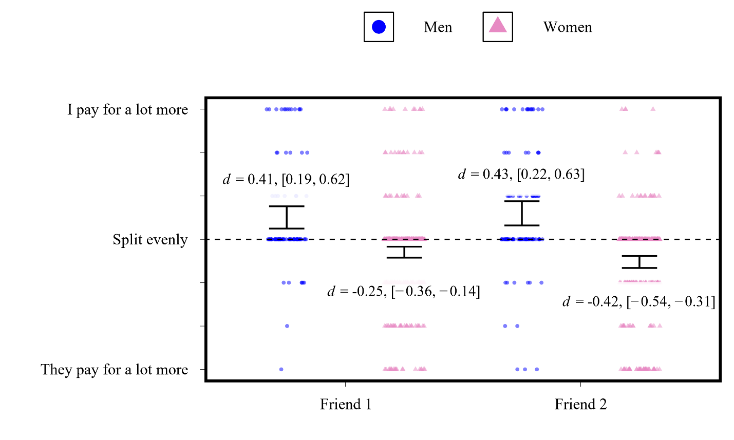
Note. All four tests compare individual mean to 4, which represents “splitting the bill evenly.” Because hypotheses were directional, one-sided tests were used with male means specified as greater and female means specified as less (all p’s < .001). Numbers in brackets represent 95% confidence interval of d.

Prediction 2: Among men, interest in mating will predict paying for more of the bill with cross-sex friends
Consistent with the PCF hypothesis (but not predicted by the FQ hypothesis), there was a significant between-person effect of mating interest on bill-paying behavior: men who were more interested in mating with their friends were more likely to pay for the bill in those friendships (β = 0.28, SE = 0.09, t(492) = 3.23, p = .001; see Figure 2 left panel). This effect was not present at the within-person level: among men, having greater mating interest in one friend relative to the other did not predict paying for a larger share of the bill with the friend toward whom they had greater mating interest (p = .563; see Figure 2 right panel).

Prediction 3: Among women, interest in mating will not predict paying for more of the bill with cross-sex friends
Consistent with the PCF hypothesis, among women mating interest was not positively associated with bill-paying behavior at either the within-person or between-person level. At the within-person level, greater mating interest in one friend relative to the other was not associated with paying for the bill with the friend they had greater mating interest in (p = .142). At the between-person level, we observed an effect in precisely opposite to that observed among men: compared to women who reported less mating interest in their friends, women who had more mating interest in their friends reported paying less of the bill (β = -0.12, SE = 0.06, t(464) = -2.05, p = .041; see Figure 2 left panel).

Figure 2
Sex differences in mating interest as a predictor of bill-paying behavior
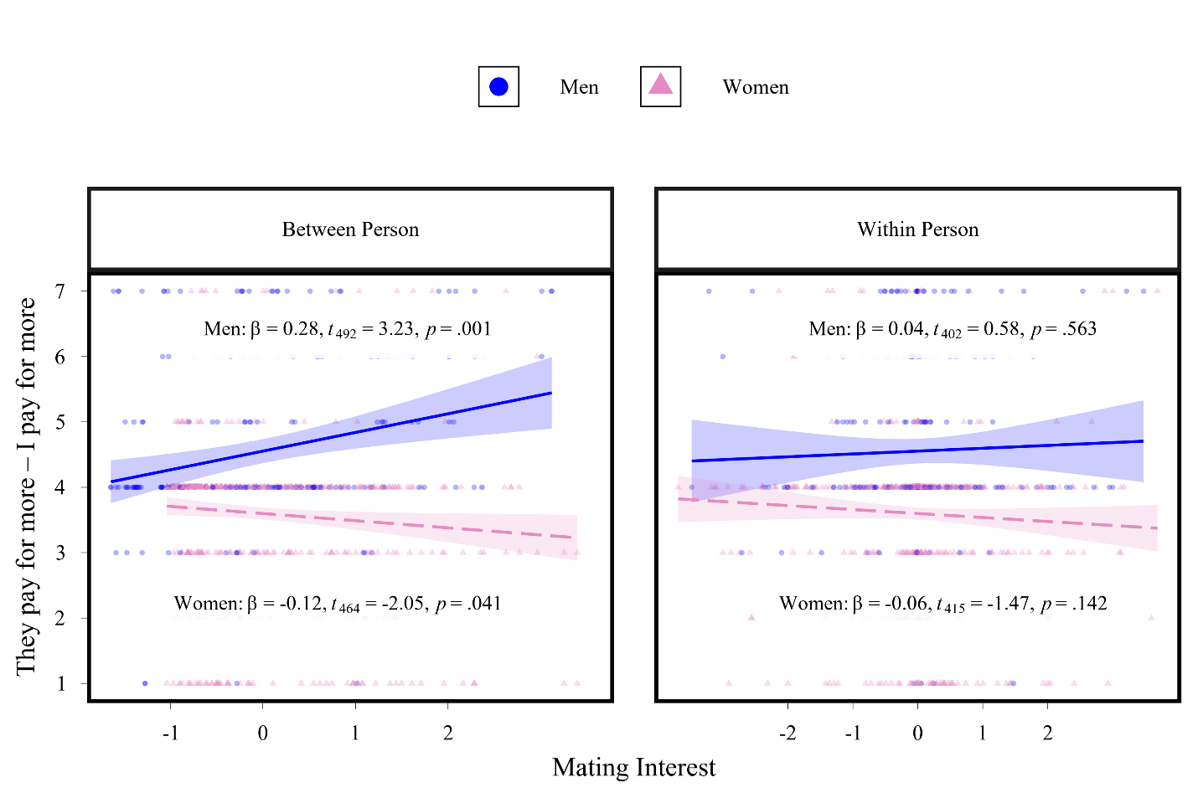

Prediction 4: Among both men and women, perceiving a cross-friendship to be high quality will predict paying for more of the bill.
Study data did not support this prediction generated by the FQ hypothesis: having higher quality friendships did not predict paying for more of the bill (between person, p = .800), and having a higher quality friendship with one friend compared to the other (within person, p = .974) did not predict paying for more of the bill with the higher quality friend.

Prediction 5: Women will perceive greater mating interest from cross-sex friends who pay for more of the bill
Consistent with the PCF hypothesis, we observed a between-person association: women who reported that their male friends pay for more of the bill with them also perceived their male friends to be more interested in mating with them, β = -0.20, SE = 0.05, t(516) = -4.03, p < .001 (see Figure 3 left panel). However, we did not observe any within-person effect: within women, one male friend paying for more of the bill compared to their other male friend did not lead to the perception that the former was more interested than the latter in mating with them (p = .171; see Figure 3 right panel).
Prediction 6: Men will not perceive greater mating interest from cross-sex friends who pay for more of the bill
Consistent with the PCF hypothesis, there was no within- or between-person associations between bill paying behavior and perceptions of mating interest from cross-sex friends (within person: p = .678, between person: p = .051; see Figure 3).
Figure 3
Sex-differentiated perceptions of a friend’s mating interest as a function of their bill-paying behavior
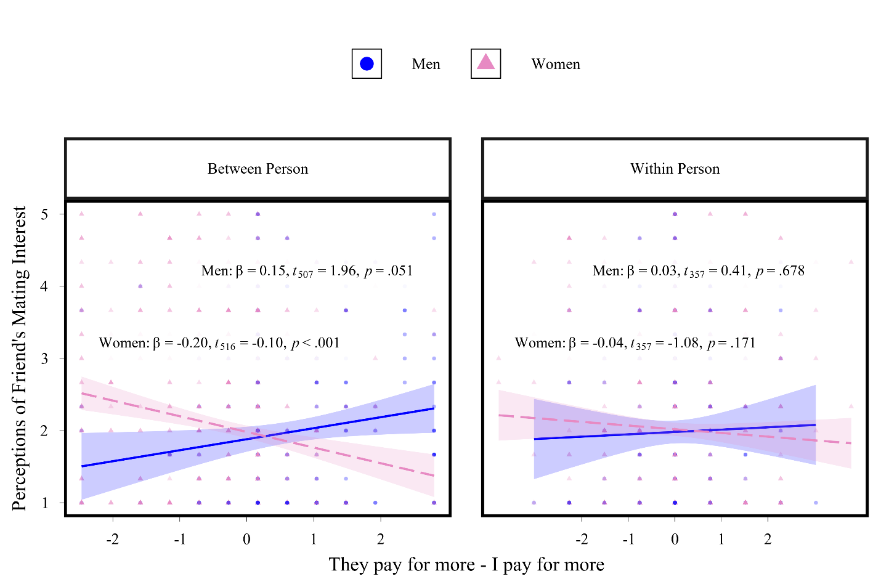

Robustness Analyses

Relationship Status
A key variable in research on mating interest in cross-sex friendships is the participant’s relationship status (i.e., single versus mated), which prior work has demonstrated is associated with experiencing attraction in cross-sex friendships (e.g., see Bleske-Rechek et al., 2012). To address this, we investigated whether participants’ relationship status moderated or accounted for the observed findings (full code is available here: https://osf.io/8dyqs/?view_only=781899619e1b4aac95de1b83b9533f03. If, for example, mating interest predicts provisioning behavior among single but not mated men, then we should expect the link between male mating interest and provisioning to be statistically moderated by relationship status (i.e., a significant relationship status x mating interest x participant sex interaction). Alternatively, the link between male mating interest and provisioning behavior could disappear entirely when relationship status is entered into the model if single but not mated men are interested in and provision their female friends. The link between men’s mating interest and their provisioning of cross-sex friends was not moderated by relationship status (relationship status x participant sex x mating interest interaction: p = .810) and was robust to its inclusion in the model: independent of relationship status, interest in mating with a cross-sex friend systematically predicted financial provisioning behavior among men but not among women (participant sex x mating interest interaction: p = .002). A parallel set of analyses on perceptions of mating interest yielded similar results: women, but not men, perceived those cross-sex friends who engaged in provisioning behavior toward them to be interested in mating with them (participant sex x provisioning behavior interaction: p < .001), an effect that did not depend on participants’ relationship status (relationship status x participant sex x provisioning behavior interaction: p = .828).

Discussion
We observed multiple forms of evidence that provide convergent, discriminative support for the Provisioning as Courtship in Friendship (PCF) hypothesis. First, replicating Bleske and Buss (2000), both men and women reported that men paid for more of the shared bills in their cross-sex friendships. Second, men’s mating interest predicted their financial investment in cross-sex friends, providing evidence for the hypothesized sex-differentiated link between provisioning and courtship. Third, women’s mating interest in their male friends was not associated with their own financial provisioning, consistent with the negative prediction of the PCF hypothesis. Fourth, women, but not men, perceived cross-sex friends who paid more of shared expenses as being more interested in mating with them. Finally, friendship quality did not account for these patterns, providing no support for the alternative Friendship Quality hypothesis. Together, these findings provide concordant lines of support for the PCF hypothesis and suggest that financial provisioning in cross-sex friendships can function as a male courtship tactic linked to mating interest.
Some Men Treat Cross-Sex Friendships as Mating Opportunities, Others Do Not: Individual Differences Vs. Contextual Effects
We found consistent evidence for between-person associations in line with the PCF hypothesis but no evidence for within-person associations. This overall pattern points more strongly toward individual differences between men rather than contextual effects. That is, the between-person associations and absence of within-person associations observed in the current study suggest that some men are more interested than others in mating with their female friends, and it is these men who engage in financial provisioning behavior toward their female friends, not that a given man who is more interested in mating with one of his female friends will engage in more financial provisioning behavior toward her than his other cross-sex friend. In other words, some men but not others may conceptualize female friends as potential mates and systematically engage in financial provisioning toward them, whereas other men do not. It is worth noting that this apparent individual difference cannot be attributed to relationship status.
Our robustness analyses (above) suggest that it is not simply the case that single men, compared to mated men, are more interested in mating with, and financial provision, their cross-sex friends. Future research is needed to elucidate these individual differences between men. Nonetheless, we present these interpretations as tentative, because this is the first study to our knowledge to disentangle such within- versus between-person effects in cross-sex friendships, and we encourage researchers to further investigate these and other sources of variation in the platonic versus mating-motivated nature of cross-sex friendships.
Limitations and Future Directions
This study has several limitations that warrant discussion, each of which points toward valuable directions for future research. First, causal conclusions remain beyond the scope of this cross-sectional, self-report design. For example, we cannot know for certain whether men are strategically attempting to signal mating interest through paying for more of the bill, as our study did not directly assess their motives. Nor can we determine conclusively whether women perceive mating interest from male friends because those friends pay for more of the bill, or whether they had already perceived interest and the financial investment merely coincides with it. That said, the observed association between men’s mating interest and their financial provisioning, together with women’s perception of male friends who for paid more of the bill when they socialized as having greater mating interest in them, provides convergent support for interpreting financial provisioning as a male courtship tactic. Future research could make this link even more explicit by asking men whether they intend their financial provisioning to signal mating interest, and by testing the effectiveness of such provisioning as a courtship tactic, either in inducing mating interest or in inviting the reciprocal expression of preexisting interest. It would also be valuable to ask women directly what cues lead them to perceive mating interest from their male friends, and to what extent financial provisioning contributes to those perceptions.
Future research is needed to understand the multiple other potential reasons for engaging in provisioning behavior in cross-sex friendships. Although research shows that women value male provisioning when it is directed toward them specifically—both in mating and friendship contexts (Barakzai & Shaw, 2018; Krems et al., 2023; Lukaszewski & Roney, 2010)—our finding that some male provisioning behavior is linked to mating interest by no means suggests that all such behavior is motivated solely by attraction. Another reason that men may engage in such provisioning behavior is that it could help cultivate a reputation for generosity (Buss et al., 2020), which could yield multiple downstream benefits, including enhanced desirability not only to the focal friend but also to her friends and other observers.
Next, because the study sample comprised young adults, the current findings may not generalize to friendships across the lifespan. Studying college students remains valuable, however, as young adulthood is a period when cross-sex friendships are especially common and often serve as pathways to romantic relationships (Stinson et al., 2022). Future studies should explore whether these patterns also pertain to older populations.
Another limitation was that the study’s bill-splitting item did not specify whether the behavior occurred in dyadic or group contexts. Group versus dyadic contexts will be important for future studies to consider for several reasons. First, group contexts could attenuate a relationship between mating interest and provisioning behavior. For example, men interested in a female friend may readily pay in one-on-one settings, but be reluctant to do so in group settings where paying for a specific individual might be seen as an overly overt courtship signal by others in the group. Second, group contexts could also motivate provisioning behavior for reasons unrelated to interest in mating with the provisioned friend. As outlined above, it is possible that some financial provisioning behavior is driven by reputational motives, such as conspicuously demonstrating generosity in front of a broader social network. Future research should more precisely measure the social context of financial provisioning, as it may moderate not only the extent to which men provision but also the motivations underlying their provisioning or lack thereof.
It is also possible that some women in the current study strategically rejected male financial provisioning, such as by insisting on splitting the bill, as a soft rejection tactic. Because both sexes tend to interpret male financial provisioning as a flirtation tactic (Wade & Feldman, 2016; Kennair et al., 2022), accepting such provisioning from a male friend may be misinterpreted as reciprocation of romantic or sexual interest. Just as accepting provisioning may be interpreted as signaling attraction, rejecting offers of financial provisioning may serve as a way to signal disinterest. This interpretation is consistent with research showing that women often manage mating dynamics through indirect strategies rather than explicit rejection (Clark et al., 1999; Wade et al., 2021). Such strategies may be particularly important in managing male expectations in friendships, especially given men’s well-documented tendency to overperceive sexual interest from female friends (Koenig et al., 2007). If some women strategically decline men’s provisioning attempts, this could attenuate observed associations between men’s mating interest and provisioning behavior, thereby masking some instances in which men are motivated to provision but are prevented from doing so by women’s rejection strategies. Future research should systematically investigate how women’s responses to financial investment function as strategic encouragement or rejection tactics within cross-sex friendships.
Finally, our sample was WEIRD (Western, Educated, Industrialized, Rich, and Democratic; Henrich et al., 2010). Future cross-cultural research should assess whether male financial investment in cross-sex friendships is a universal or culture-specific mating strategy. The present finding that men reported greater financial provisioning in cross-sex friendships than women emerging even with participants being embedded in relatively egalitarian courtship norms, suggests that these sex differences are not easily attributable to traditional gender conventions.
Future research should test whether these provisioning patterns are moderated by broader mating-market ecology. Local sex ratio, for example, can shift competitive dynamics and may recalibrate the extent to which investment is required to secure mates (e.g., Moss & Maner, 2016; Walter et al., 2021). In male-biased environments, where competition among men is heightened, financial provisioning may become a more frequent courtship signal, potentially amplifying the observed sex difference. In female-biased environments, by contrast, reduced competition may attenuate the magnitude of male provisioning behavior.
Socioeconomic status (SES) may similarly moderate these effects, because the marginal cost—and thus the signaling value—of financial provisioning differs across individuals. Higher-SES men may provision more frequently at lower subjective cost, whereas lower-SES men may deploy provisioning more selectively when mating interest is especially strong. Thus, variation in the magnitude or selectivity of provisioning across SES levels would not undermine the PCF hypothesis but would instead reflect calibration of courtship effort to ecological and economic constraints. Testing the PCF hypothesis across sex-ratio and socioeconomic ecologies would help clarify when and for whom male provisioning in cross-sex friendships is most pronounced.
Future Theoretical Directions
In the current study, we focused only on the Provisioning-as-Courtship in Cross-Sex Friendship Hypothesis, which can be thought of as one specific derivation of a broader Courtship in Friendship Hypothesis. This framework proposes that people deploy mate-attraction tactics even within ostensibly platonic friendships, and that the precise form of these behaviors should be guided by the mate preferences of the opposite sex. By articulating this overarching framework and providing the first empirical evidence for one candidate behavior; male financial provisioning, we establish a foundation for the systematic investigation of other courtship tactics in cross-sex friendships. Future work might extend this framework to other courtship tactics that may surface in cross-sex friendships, such as men displaying traits valued by women, like formidability (Sell et al., 2009) and humor (Greengross, 2014), women emphasizing traits prioritized by men, like physical attractiveness (Buss, 1989; Walter et al., 2020), or both sexes derogating rivals or their friends’ prospective mates (Schmitt & Buss, 1996).
Future research should examine whether cross-sex friends strategically emphasize these qualities more in the presence of cross-sex friends toward whom they harbor mating interest. Such work would provide a more comprehensive test of the overarching Courtship in Friendship Hypothesis and further reveal the range of mating strategies expressed in ostensibly platonic friendships. We hope the Courtship in Friendship Hypothesis will serve as a useful framework for future research on the diverse ways that mating motivations shape friendship dynamics
Conclusion
This study’s multiple supported predictions provide convergent evidence that male financial provisioning behavior in cross-sex friendships is systematically linked to mating interest, and is perceived as such by women. Moreover, our study design, which enabled us to isolate within-person versus between-person effects revealed previously unexplored nuance to these associations. Specifically, the current study data suggest that these associations are better explained by stable between-person differences in men’s propensities, rather than by within-person contextual effects. In other words, it was not that the same men provisioned more for one female friend over another depending on his level of attraction (a within-person effect); instead, some men consistently provisioned more across friendships, whereas others did not (a between-person effect). These findings suggest that cross-sex friendships are associated with mating motivations more for some people than others, which may lend insight into the observed variation in the platonic versus mating outcomes of cross-sex friendships. We eagerly await future research that builds on these initial observations, which can be used to help individuals better navigate the complexities of cross-sex friendships.

References

Afifi, W. A., & Faulkner, S. L. (2000). On being ‘just friends’: The frequency and impact of sexual activity in cross-sex friendships. Journal of Social and Personal Relationships, 17(2), 205-222. https://doi.org/10.1177/0265407500172003
Apostolou, M. (2024). Forging Close Friendships: Strategies for Strengthening Friendships People Consider Desirable, and the Role of Personality. Evolutionary Psychological Science, 10(4), 303-314. https://doi.org/10.1007/s40806-024-00410-6
Apostolou, M., & Keramari, D. (2020). What prevents people from making friends: A taxonomy of reasons. Personality and Individual Differences, 163, 110043.
Apostolou, M., & Keramari, D. (2022). Why friendships end: An evolutionary examination. Evolutionary Behavioral Sciences, 16(4), 301. https://doi.org/10.1037/ebs0000269
Apostolou, M., & Vetsa, P. (2023). Friendship preferences: Examining desirable and undesirable traits in a friend. Evolutionary Psychological Science, 9(1), 38-49. https://doi.org/10.1016/j.paid.2020.110043
Apostolou, M., Sullman, M., Birkás, B., Błachnio, A., Bushina, E., Calvo, F., Costello, W., Dujlovic, T., Hill, T., Lisun, Y., Manrique-Millones, D., Manrique-Pino, O., Meskó, N., Nechtelberger, M., Ohtsubo, Y., Ollhoff, C. K., Przepiórka, A., Putz, Á., Tagliabue, M., … Font-Mayolas, S. (2023). Strategies for becoming a more desirable mate: Evidence from 14 countries. Personal Relationships. Advance online publication. https://doi.org/10.1111/pere.12521
Apostolou, M., Sullman, M. J. M., Ayers, J. D., Błachnio, A., Choubisa, R., Gadelrab, H. F., Hill, T., Kamble, S., Lisun, Y., Manrique-Millones, D., Millones-Rivalles, R., Ohtsubo, Y., Przepiórka, A., Tekeş, B., Vera Cruz, G., Wang, Y., Watanabe, Y., & Ghorbani, A. (2024). Why people make friends: Evidence from 12 nations. Personality and Individual Differences, 229, 112774. https://doi.org/10.1016/j.paid.2024.112774
Ayers, J. D., Krems, J. A., & Aktipis, A. (2023). A factor analytic examination of women's and men's friendship preferences. Personality and Individual Differences, 206, 112120. https://doi.org/10.1016/j.paid.2023.112120
Barakzai, A., & Shaw, A. (2018). Friends without benefits: When we react negatively to helpful and generous friends. Evolution and Human Behavior, 39(5), 529-537. https://doi.org/10.1016/j.evolhumbehav.2018.05.004
Baumeister, R. F., & Vohs, K. D. (2004). Sexual economics: Sex as female resource for social exchange in heterosexual interactions. Personality and Social Psychology Review, 8(4), 339-363. https://doi.org/10.1007/s12115-012-9596-y
Baumeister, R. F., Reynolds, T., Winegard, B., & Vohs, K. D. (2017). Competing for love: Applying sexual economics theory to mating contests. Journal of Economic Psychology, 63, 230-241. https://doi.org/10.1016/j.joep.2017.07.009
Blake, K. R. (2022). Attractiveness helps women secure mates, but also status and reproductively relevant resources. Archives of Sexual Behavior, 51(1), 39-41. https://doi.org/10.1007/s10508-021-01949-2
Blieszner, R., & Adams, R. G. (1992). Adult friendship. Sage Publications.
Bleske, A. L., & Buss, D. M. (2000). Can men and women be just friends? Personal Relationships, 7(2), 131-151. https://psycnet.apa.org/doi/10.1111/j.1475-6811.2000.tb00008.x
Bleske-Rechek, A. L., & Buss, D. M. (2001). Opposite-sex friendship: Sex differences and similarities in initiation, selection, and dissolution. Personality and Social Psychology Bulletin, 27(10), 1310-1323. https://doi.org/10.1177/01461672012710007
Bleske-Rechek, A., Somers, E., Micke, C., Erickson, L., Matteson, L., Stocco, C., Schumacher, B., & Ritchie, L. (2012). Benefit or burden? Attraction in cross-sex friendship. Journal of Social and Personal Relationships, 29(5), 569-596. https://doi.org/10.1177/0265407512443611
Buss, D. M. (1988). The evolution of human intrasexual competition: tactics of mate attraction. Journal of Personality and Social Psychology, 54(4), 616. DOI: 10.1037//0022-3514.54.4.616
Buss, D. M. (1989). Sex differences in human mate preferences: Evolutionary hypotheses tested in 37 cultures. Behavioral and Brain Sciences. 12(1):1-14. doi:10.1017/S0140525X00023992
Buss, D. M., Goetz, C., Duntley, J. D., Asao, K., & Conroy-Beam, D. (2017) The mate switching hypothesis. Personality and Individual Differences, 104, 143-149. http://dx.doi.org/10.1016/j.paid.2016.07.022
Buss, D. M., & Schmitt, D. P. (2019). Mate preferences and their behavioral manifestations. Annual Review of Psychology, 70, 77–110. https://doi.org/10.1146/annurev-psych-010418-103408
Buss, D. M., Durkee, P. K., Shackelford, T. K., Bowdle, B. F., Schmitt, D. P., Brase, G. L., Choe, J. C., & Trofimova, I. (2020). Human status criteria: Sex differences and similarities across 14 nations. Journal of Personality and Social Psychology, 119(5), 979–998. https://doi.org/10.1037/pspa0000206
Chen, R., Sun, H., Guo, Z., & Chen, H. A. (2025). He loves the one he has Invested in: the effects of mating cues on men’s and women’s sunk cost Bias. Journal of Consumer Research, 51(6), 1098-1119. DOI: 10.1093/jcr/ucae048
Clark, C. L., Shaver, P. R., & Abrahams, M. F. (1999). Strategic behaviors in romantic relationship initiation. Personality and Social Psychology Bulletin, 25(6), 709-722.
Collisson, B., Howell, J. L., & Harig, T. (2020). Foodie calls: When women date men for a free meal (rather than a relationship). Social Psychological and Personality Science, 11(3), 425-432. https://doi.org/10.1177/1948550619856308
Eaton, A. A., & Rose, S. (2011). Has dating become more egalitarian? A 35 year review using sex roles. Sex roles, 64(11), 843-862. https://doi.org/10.1007/s11199-011-9957-9
Fehr, B. (1996). Friendship processes (Vol. 12). Sage.
Gomes, C. M., & Boesch, C. (2009). Wild chimpanzees exchange meat for sex on a long-term basis. PloS one, 4(4), e5116. https://doi.org/10.1371/journal.pone.0005116
Greengross, G. (2014). Male production of humor produced by sexually selected psychological adaptations. In V. Weekes-Shackelford & T. Shackelford (Eds.), Evolutionary perspectives on human sexual psychology and behavior (pp. 173–196). Springer. https://doi.org/10.1007/978-1-4939-0314-6_9
Halatsis, P., & Christakis, N. (2009). The challenge of sexual attraction within heterosexuals’ cross-sex friendship. Journal of social and Personal Relationships, 26(6), 919-937. https://doi.org/10.1177/0265407509345650
Henrich, J., Heine, S. J., & Norenzayan, A. (2010). Most people are not WEIRD. Nature, 466(7302), 29-29. https://doi.org/10.1038/466029a
Iredale, W., Van Vugt, M., & Dunbar, R. (2008). Showing off in humans: Male generosity as a mating signal. Evolutionary Psychology, 6(3), 147470490800600302. https://doi.org/10.1177/147470490800600302
Jonason, P. K., Cetrulo, J. F., Madrid, J. M., & Morrison, C. (2009). Gift-giving as a courtship or mate-retention tactic?: Insights from non-human models. Evolutionary Psychology, 7(1), 147470490900700112.
Kenrick, D. T., Neuberg, S. L., Griskevicius, V., Becker, D. V., & Schaller, M. (2010). Goal-Driven Cognition and Functional Behavior: The Fundamental-Motives Framework: The Fundamental-Motives Framework. Current Directions in Psychological Science, 19(1), 63-67. https://doi.org/10.1177/0963721409359281
Kennair, L. E. O., Wade, T. J., Tallaksen, M. T., Grøntvedt, T. V., Kessler, A. M., Burch, R. L., & Bendixen, M. (2022). Perceived effectiveness of flirtation tactics: The effects of sex, mating context and individual differences in US and Norwegian samples. Evolutionary Psychology, 20(1), 14747049221088011. https://doi.org/10.1177/14747049221088011
Koenig, B. L., Kirkpatrick, L. A., & Ketelaar T. (2007) Misperception of sexual and romantic interests in opposite-sex friendships: Four hypotheses. Personal Relationships, 14(3), 411-429. https://doi.org/10.1111/j.1475-6811.2007.00163.x
Komiya, A., Ohtsubo, Y., Nakanishi, D., & Oishi, S. (2019). Gift-giving in romantic couples serves as a commitment signal: Relational mobility is associated with more frequent gift-giving. Evolution and Human Behavior, 40(2), 160-166. https://doi.org/10.1016/j.evolhumbehav.2018.10.003
Krems, J. A., & Conroy-Beam, D. (2020). First tests of Euclidean preference integration in friendship: Euclidean friend value and power of choice on the friend market. Evolution and Human Behavior, 41(3), 188-198. https://doi.org/10.1016/j.evolhumbehav.2020.02.003
Krems, J. A., & Kaufman, V. A. (2025). Friendship: The Most Overlooked Public Health Asset. Policy Insights from the Behavioral and Brain Sciences, 13(1), 93-100. https://doi.org/10.1177/23727322251404386
Krems, J. A., Williams, K. E., Aktipis, A., & Kenrick, D. T. (2021). Friendship jealousy: One tool for maintaining friendships in the face of third-party threats?. Journal of Personality and Social Psychology, 120(4), 977. https://doi.org/10.1037/pspi0000311
Krems, J. A., Williams, K. E., Merrie, L. A., Kenrick, D. T., & Aktipis, A. (2022). Sex (similarities and) differences in friendship jealousy. Evolution and Human Behavior, 43(2), 97-106. https://doi.org/10.1016/j.evolhumbehav.2021.11.005
Krems, J. A., Hahnel-Peeters, R. K., Merrie, L. A., Williams, K. E., & Sznycer, D. (2023). Sometimes we want vicious friends: People have nuanced preferences for how they want their friends to behave toward them versus others. Evolution and Human Behavior, 44(2), 88-98. https://doi.org/10.1016/j.evolhumbehav.2023.02.008
Kruger, D. J. (2008). Male financial consumption is associated with higher mating intentions and mating success. Evolutionary Psychology, 6(4), 147470490800600407.
Lewis, D. M.G., Conroy-Beam, D., Al-Shawaf, L., Raja, A., Dekay, T., & Buss, D. M. (2011). Friends with benefits: The evolved psychology of same- and opposite-sex friendship. Evolutionary Psychology, 9(4), 543-563. https://psycnet.apa.org/doi/10.1177/147470491100900407
Lewis, D. M. G., Al-Shawaf, L., Conroy-Beam, D., Asao, K., & Buss, D. M. (2017). Evolutionary psychology: A how-to guide. American Psychologist, 72(4), 353–373. https://doi.org/10.1037/a0040409
Lewis, D. M.G., Al-Shawaf, L., Conroy-Beam, D., Asao, K., & Buss, D. M. (2012). Friends with benefits II: Mating activation in opposite-sex friendships as a function of sociosexual orientation and relationship status. Personality and Individual Differences, 53(5), 622-628. http://dx.doi.org/10.1016/j.paid.2012.04.040
Lewis, D. M., Al-Shawaf, L., Russell, E. M., & Buss, D. M. (2015). Friends and happiness: An evolutionary perspective on friendship. In Friendship and happiness: Across the life-span and cultures (pp. 37-57). Dordrecht: Springer Netherlands. https://doi.org/10.1007/978-94-017-9603-3_3
Lukaszewski, A. W., & Roney, J. R. (2010). Kind toward whom? Mate preferences for personality traits are target specific. Evolution and Human Behavior, 31(1), 29-38. https://doi.org/10.1016/j.evolhumbehav.2009.06.008
Moss, J. H., & Maner, J. K. (2016). Biased sex ratios influence fundamental aspects of human mating. Personality and Social Psychology Bulletin, 42(1), 72-80. https://doi.org/10.1177/0146167215612744
Ömür, M., & Büyükşahin-Sunal, A. (2015). Preferred strategies for female and male initiators in romantic relationship initiation: The role of stereotypes related to romantic relationships, rejection sensitivity and relationship anxiety. Journal of Educational and Social Research, 5(1), 476-482. doi:10.5901/jesr.2015.v5n1s1p195
Orhan, M. A., Collisson, B., Howell, J. L., Kowal, M., & Pollet, T. V. (2025). Comparing Foodie Calls in Poland, the United Kingdom, and the United States: A Registered Replication Report. Psychological Reports, 128(2), 1004-1023.
Roney, J. R. (2003). Effects of visual exposure to the opposite sex: Cognitive aspects of mate attraction in human males. Personality and Social Psychology Bulletin, 29(3), 393-404. https://doi.org/10.1177/0146167202250221
Schmitt, D. P., & Buss, D. M. (1996). Strategic self-promotion and competitor derogation: sex and context effects on the perceived effectiveness of mate attraction tactics. Journal of Personality and Social Psychology, 70(6), 1185. DOI 10.1037/0022-3514.70.6.1185
Schneider, C. S., & Kenny, D. A. (2000). Cross-sex friends who were once romantic partners: Are they platonic friends now?. Journal of Social and Personal Relationships, 17(3), 451-466. https://doi.org/10.1177/0265407500173007
Sell, A., Lukazsweski, A. W., & Townsley, M. (2017). Cues of upper body strength account for most of the variance in men's bodily attractiveness. Proceedings of the Royal Society B: Biological Sciences, 284(1869), 20171819. https://doi.org/10.1098/rspb.2017.1819
Stewart-Williams, S., & Thomas, A. G. (2013). The ape that thought it was a peacock: Does evolutionary psychology exaggerate human sex differences?. Psychological Inquiry, 24(3), 137-168. https://doi.org/10.1080/1047840X.2013.804899
Stinson, D. A., Cameron, J. J., & Hoplock, L. B. (2022). The friends-to-lovers pathway to romance: Prevalent, preferred, and overlooked by science. Social Psychological and Personality Science, 13(2), 562-571. https://doi.org/10.1177/19485506211026992
Sundie, J. M., Kenrick, D. T., Griskevicius, V., Tybur, J. M., Vohs, K. D., & Beal, D. J. (2011). Peacocks, Porsches, and Thorstein Veblen: conspicuous consumption as a sexual signaling system. Journal of Personality and Social Psychology, 100(4), 664. https://doi.org/10.1037/a0021669
Symons, D. (1979). The evolution of human sexuality. New York, NY: Oxford University Press.
Szymkow, A., & Frankowska, N. (2022). Moderators of sexual interest in opposite-sex friends. Evolutionary Psychology, 1-14. https://doi.org/10.1177/14747049211068672
Tooby, J., & Cosmides, L. (1996, January). Friendship and the banker's paradox: Other pathways to the evolution of adaptations for altruism. In Proceedings-British Academy (Vol. 88, pp. 119-144). Oxford University Press Inc.
Trivers, R. (1972). Parental investment and sexual selection. In B. Campbell (Ed.), Sexual selection and the descent of man (pp. 136–179). Aldine-Atherton.
Vahed, K. (1998). The function of nuptial feeding in insects: a review of empirical studies. Biological Reviews, 73(1), 43-78.
Wade, T. J., & Feldman, A. (2016). Sex and the perceived effectiveness of flirtation techniques. Human Ethology Bulletin, 31(2), 30.
Wade, T. J., Fisher, M. L., & Clark, E. (2021). I saw him first: Competitive nonverbal flirting among women, the tactics used and their perceived effectiveness. Personality and Individual Differences, 179, 110898.
Walter, K. V., Conroy-Beam, D., Buss, D. M., Asao, K., Sorokowska, A., Sorokowski, P., Aavik, T., Akello, G., Alhabahba, M. M., Alm, C., Amjad, N., Anjum, A., Atama, C. S., Atamtürk Duyar, D., Ayebare, R., Batres, C., Bendixen, M., Bensafia, A., Bizumic, B., … Zupančič, M. (2020). Sex Differences in Mate Preferences Across 45 Countries: A Large-Scale Replication. Psychological Science, 31(4), 408- 423. https://doi.org/10.1177/0956797620904154
Wahring, I. V., Simpson, J. A., & Van Lange, P. A.M. (2025) Romantic relationships matter more to men than to women. Behavioral and Brain Sciences. Advance online publication. https://doi.org/10.1017/S0140525X24001365
Walter, K. V., Conroy-Beam, D., Buss, D. M., Asao, K., Sorokowska, A., Sorokowski, P., Aavik, T., Akello, G., Alhabahba, M. M., Alm, C., Amjad, N., Anjum, A., Atama, C. S., Atamtürk Duyar, D., Ayebare, R., Batres, C., Bendixen, M., Bensafia, A., Bizumic, B., … Zupančič, M. (2021). Sex differences in human mate preferences vary across sex ratios. Proceedings of the Royal Society B: Biological Sciences, 288(1955), Article 20211115. https://doi.org/10.1098/rspb.2021.1115
Zinbarg, R. E., Revelle, W., Yovel, I., & Li, W. (2005). Cronbach’s α, Revelle’s β, and McDonald’s ωH: Their relations with each other and two alternative conceptualizations of reliability. psychometrika, 70(1), 123-133. DOI: https://doi.org/10.1007/s11336-003- 0974-7

For complete transparency, the uncleaned data file and code used to clean the data are available on the Open Science Framework.
The final ~8% of the sample reported they were casually dating one or more people (5.7%, n =33), were in serious relationship with more than one person (1.2%, n = 7), or did not provide their relationship status (1.9%, n = 11).
Whenever “FRIEND” is contained within a question, the name, nickname, or initials of Friend 1 or Friend 2, provided by participants, was piped into the question by the survey software to ensure that participants were responding to the correct friend for each question.

